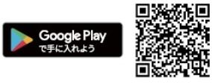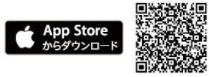

Contact:

Fukuyama City Crisis Management

Disaster Prevenion Division

(Fukuyama-shi Kikikanri Bousai Ka)

Tel 084-928-1228

You can receive information through push notifications without opening the app.

With the cooperation of 1st Media Corporation, this app was developed to show users the way to the nearest evacuation area. Those who have smartphones, please download and use it to receive notifications from Fukuyama City and weather information not only in Japanese but also in English, Chinese (simplified and traditional characters) and Korean.

## **English**

② You can find the way to evacuation areas.

　 You can see where you are now on the map.

You can also find the way to the nearest evacuation

area which appears on the map.

　 You can check other maps and hazard maps.

③ Support for foreign languages

Depending on your language setting of your

smartphone, you can see information in foreign

languages.

※It will be supported by 11 foreign languages by the 2020 Tokyo Olympics.

If you tap the sign of evacuation area on the map, you can search for the route.

Please search and download ‘Japan Shelter Guide’ in the App Store or Google Play using your smartphone or other devices.

1. You can receive notifications from Fukuyama City.

　 You can receive notifications from Fukuyama

City such as [にげてください] (=Nigete kudasai. Please evacuate.) without opening the app.

(Not all notifications may arrive.)

## ２　What you can do with this app

## １　Download the app

Be prepared!

Disaster Prevention App

“Japan Shelter Guide”

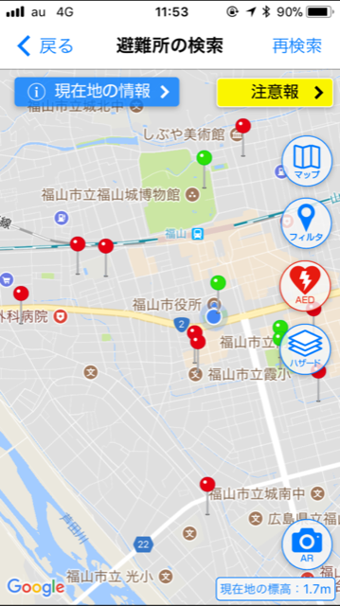

避難所ガイド

避難勧告

**※イメージ**

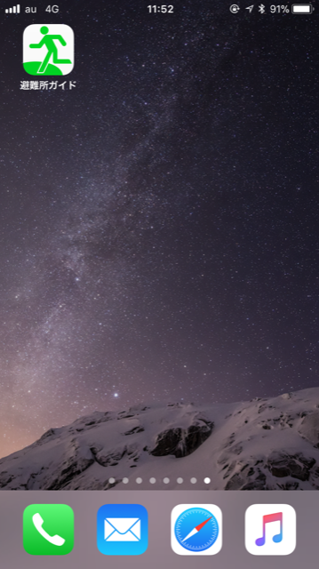

【確認】

英語でポップアップは表示される？

トランスレートは正しい？